SIMATS ENGINEERING
ASSESSMENT TOOL 2
COURSE NAME | INTERNET PROGRAMMING
COURSE CODE | CSA43
NAME | K VENKATA SIVA PRASAD
REGISTER NUMBER | 192325106

COURSE OUTCOME COVERED
CO-2: Apply CSS layout and styling techniques to create visually appealing and responsive web interfaces, and use JavaScript to enable interactive client-side behavior. (L3)
Assessment Tool: Design Task Weightage: 20%

Question 1: Responsive Navigation Bar Design
Suppose that an e-commerce website requires a responsive navigation bar that adapts across desktop, tablet and mobile devices. (a) Identify key components required in a navigation bar for an e-commerce website. (b) Design a responsive navigation bar using appropriate CSS techniques. (c) Demonstrate how the navigation adapts to smaller screens (for example, a hamburger menu). (d) Evaluate the usability and suggest improvements for better user experience.

SOLUTION:
(a) Key components of an e-commerce navigation bar
The navigation bar is the first thing a shopper uses, so it must let the visitor find products, check the cart and reach their account with as few clicks as possible. Table 1 lists the components that an online store needs.
Component | Purpose | Why it is needed
Brand logo | Names the store and links to the home page | Gives identity and an easy way back to the start
Primary links | Home, Shop, Deals, My Account | Quick access to the main sections
Search bar | Finds a product by name or keyword | Most shoppers search instead of browsing
Cart icon with count badge | Shows the number of items in the cart | Keeps the purchase status visible and leads to checkout
Account / login link | Orders, wishlist, profile | Supports returning customers
Hamburger toggle | Collapses the menu on small screens | Saves space on phones

(b) Responsive navigation bar using CSS techniques
The bar is designed mobile-first: the basic CSS describes the phone layout, and a media query at 768 px rearranges the same elements into one horizontal row. The main techniques are summarised in Table 2.
CSS technique | How it is used in the navigation bar
Flexbox with flex-wrap | Places logo, cart, burger, search and menu in one container; items wrap to a new line on narrow screens
order property | Changes the visual order in each layout without changing the HTML
Media query (min-width: 768px) | Switches from the stacked phone layout to a single row on tablets and desktops
Checkbox hack (:checked ~ .menu) | Opens and closes the mobile menu without any JavaScript
position: sticky | Keeps the bar (and the cart) at the top while the page scrolls

HTML & CSS CODE:
<!DOCTYPE html>
<html lang="en">
<head>
<meta charset="UTF-8">
<meta name="viewport" content="width=device-width, initial-scale=1.0">
<title>Responsive Navigation Bar</title>
<style>
* { box-sizing: border-box; margin: 0; padding: 0; }
body { font-family: Arial, sans-serif; background: #f4f6fa; }
a { color: inherit; text-decoration: none; }

/* Mobile first: logo, cart and burger on row 1, search on row 2 */
.navbar { display: flex; flex-wrap: wrap; align-items: center;
gap: 0.6rem 1rem; padding: 0.7rem 1rem; background: #0f2547;
color: #fff; position: sticky; top: 0; }
.brand { order: 1; flex: 1; font-size: 1.4rem; font-weight: bold; }
.brand span { color: #ffb703; }
.cart { order: 2; position: relative; padding: 0.4rem 0.6rem; }
.cart b { position: absolute; top: -4px; right: -4px; background: #e63946;
border-radius: 50%; font-size: 0.7rem; padding: 2px 6px; }
.burger { order: 3; font-size: 1.7rem; cursor: pointer; }
#nav-toggle { display: none; }
.search { order: 4; flex: 0 0 100%; display: flex; gap: 0.4rem; }
.search input { flex: 1; padding: 0.55rem; border: 0; border-radius: 4px; }
.search button { padding: 0.55rem 0.9rem; border: 0; border-radius: 4px;
background: #ffb703; font-weight: bold; }
.menu { order: 5; flex: 0 0 100%; display: none; list-style: none; }
.menu a { display: block; padding: 0.85rem 0.2rem;
border-top: 1px solid #2c4470; }
.menu a:hover, .menu a:focus { color: #ffb703; }
#nav-toggle:checked ~ .menu { display: block; }

/* Tablet and desktop: one horizontal row */
@media (min-width: 768px) {
.navbar { padding: 0.8rem 2rem; }
.burger { display: none; }
.brand { flex: 0 0 auto; }
.menu { order: 2; flex: 1; display: flex; justify-content: center;
gap: 1.2rem; }
.menu a { border: 0; padding: 0.4rem 0.6rem; }
.search { order: 3; flex: 0 0 260px; }
.cart { order: 4; }
}
main { padding: 1.5rem 1rem; }
</style>
</head>
<body>
<nav class="navbar" aria-label="Main navigation">
<a class="brand" href="#">Shop<span>Kart</span></a>
<a class="cart" href="#" aria-label="Cart with 3 items">Cart <b>3</b></a>
<label class="burger" for="nav-toggle" aria-label="Toggle menu">&#9776;</label>
<input type="checkbox" id="nav-toggle">
<ul class="menu">
<li><a href="#">Home</a></li>
<li><a href="#">Shop</a></li>
<li><a href="#">Deals</a></li>
<li><a href="#">My Account</a></li>
</ul>
<form class="search" role="search">
<input type="search" placeholder="Search products" aria-label="Search">
<button type="submit">Go</button>
</form>
</nav>
<main><h2>Today's Offers</h2></main>
</body>
</html>
(c) How the navigation adapts to smaller screens
Screen | Layout | Behaviour
Desktop (1000 px +) | Logo, links, search and cart in one row | Hamburger icon is hidden; all links are visible
Tablet (768 px – 999 px) | Same single row with a narrower gap | Search keeps a fixed width of 260 px
Mobile (below 768 px) | Logo, cart and burger on row 1; search on row 2 | Links are hidden; tapping the burger shows them as a stacked list

OUTPUT:
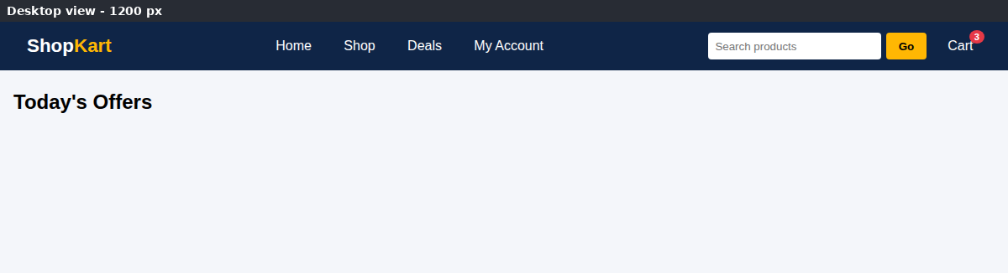
Figure 1: Desktop view of the navigation bar
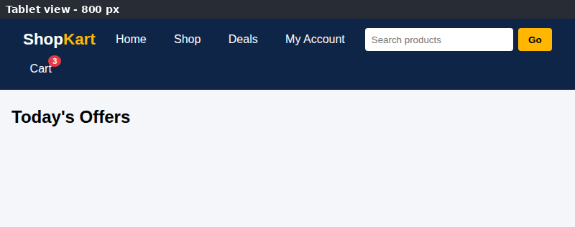
Figure 2: Tablet view
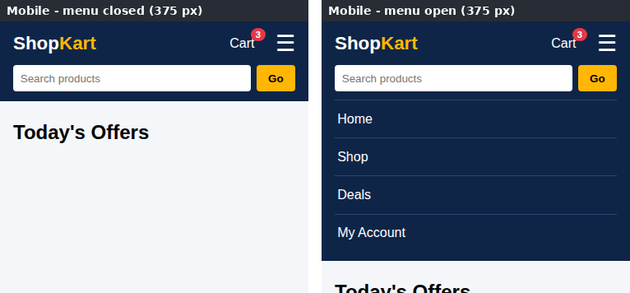
Figure 3: Mobile view with the menu closed and opened using the hamburger icon
(d) Usability evaluation and improvements
Aspect | Evaluation | Improvement
Visibility | Search and cart stay visible on every device | Show a mini-cart preview on hover or tap
Touch targets | Menu links have 0.85 rem padding and are easy to tap | Keep every target at least 44 px high
Accessibility | Labels and aria-labels are present, but the checkbox hack cannot update aria-expanded | Use a button with a small script that toggles aria-expanded
Performance | No JavaScript is needed for the menu | Keep the CSS small and avoid heavy icon fonts
Findability | Search is a plain text box | Add auto-suggestions and recent searches
Orientation | Links give hover colour feedback | Highlight the current page and add a category mega-menu

Question 2: Product Hover Effect
Suppose that an e-commerce website wants to enhance user interaction through visual effects on product items. (a) Identify suitable CSS properties for hover effects. (b) Suggest an appropriate CSS animation or transition for product interaction. (c) Design a hover effect for a product card. (d) Evaluate performance and user experience considerations.

SOLUTION:
(a) Suitable CSS properties for hover effects
Property | Effect on the product card | Cost
transform | translateY() lifts the card; scale() zooms the image | Very low (GPU compositor)
opacity | Fades the “Add to Cart” button in and out | Very low
box-shadow | A deeper shadow gives a sense of depth | Medium (needs repaint)
filter | brightness() or grayscale() changes the product image | Medium
background-color / border-color | Colour feedback on buttons and links | Low
cursor: pointer | Shows the item is clickable | None

(b) Appropriate CSS transition or animation
A hover effect is a change between two states (normal and hover), so a CSS transition is the right tool: the browser calculates the in-between frames and reverses them automatically when the mouse leaves. A @keyframes animation is better for effects that run on their own, such as a pulsing “New” badge.
Feature | Transition | @keyframes animation
Trigger | Needs a state change such as :hover | Can start automatically and repeat
Steps | Only start and end state | Any number of intermediate steps
Best use here | Lift, zoom and button fade | Pulsing “New” badge

A duration of 0.2 s to 0.4 s with the ease timing function feels quick without being distracting, for example: transition: transform .3s ease.
(c) Design of the product card hover effect
On hover (or keyboard focus) four things happen together: the card moves up by 8 px, the shadow becomes deeper, the picture zooms slightly inside its frame, and the hidden “Add to Cart” button fades in and slides into place. A small pulsing badge marks new products.
HTML & CSS CODE:
<!DOCTYPE html>
<html lang="en">
<head>
<meta charset="UTF-8">
<meta name="viewport" content="width=device-width, initial-scale=1.0">
<title>Product Card Hover Effect</title>
<style>
* { box-sizing: border-box; margin: 0; padding: 0; }
body { font-family: Arial, sans-serif; background: #eef1f6; }
.grid { display: flex; flex-wrap: wrap; justify-content: center;
gap: 24px; padding: 40px 16px; }
.card { position: relative; width: 220px; background: #fff;
border-radius: 12px; overflow: hidden; text-align: center;
box-shadow: 0 2px 8px rgba(0, 0, 0, .12);
transition: transform .3s ease, box-shadow .3s ease; }
.card:hover, .card:focus-within {
transform: translateY(-8px);
box-shadow: 0 16px 28px rgba(0, 0, 0, .22); }
.thumb { height: 140px; overflow: hidden; }
.thumb div { height: 100%; transition: transform .4s ease; }
.card:hover .thumb div { transform: scale(1.12); }
.card:nth-child(1) .thumb div { background: linear-gradient(135deg,#ff9a8b,#ff6a88); }
.card:nth-child(2) .thumb div { background: linear-gradient(135deg,#84fab0,#2a9d8f); }
.card:nth-child(3) .thumb div { background: linear-gradient(135deg,#a1c4fd,#3a56d4); }
.badge { position: absolute; top: 10px; left: 10px; background: #e63946;
color: #fff; font-size: 12px; padding: 3px 9px; border-radius: 10px;
animation: pulse 2s infinite; }
@keyframes pulse { 0%, 100% { transform: scale(1); } 50% { transform: scale(1.12); } }
.info { padding: 14px; }
.info h3 { font-size: 1rem; }
.price { color: #2a6f4f; font-weight: bold; margin: 4px 0 10px; }
.add { padding: 8px 18px; border: 0; border-radius: 20px;
background: #0f2547; color: #fff; cursor: pointer;
opacity: 0; transform: translateY(10px);
transition: opacity .3s ease, transform .3s ease; }
.card:hover .add, .card:focus-within .add { opacity: 1; transform: none; }
@media (hover: none) { .add { opacity: 1; transform: none; } }
@media (prefers-reduced-motion: reduce) {
.card, .thumb div, .add { transition: none; }
.badge { animation: none; }
}
</style>
</head>
<body>
<section class="grid">
<article class="card"><span class="badge">New</span>
<div class="thumb"><div></div></div>
<div class="info"><h3>Running Shoes</h3><p class="price">Rs. 2,499</p>
<button class="add">Add to Cart</button></div></article>
<article class="card">
<div class="thumb"><div></div></div>
<div class="info"><h3>Water Bottle</h3><p class="price">Rs. 599</p>
<button class="add">Add to Cart</button></div></article>
<article class="card">
<div class="thumb"><div></div></div>
<div class="info"><h3>Bluetooth Speaker</h3><p class="price">Rs. 1,799</p>
<button class="add">Add to Cart</button></div></article>
</section>
</body>
</html>
OUTPUT:
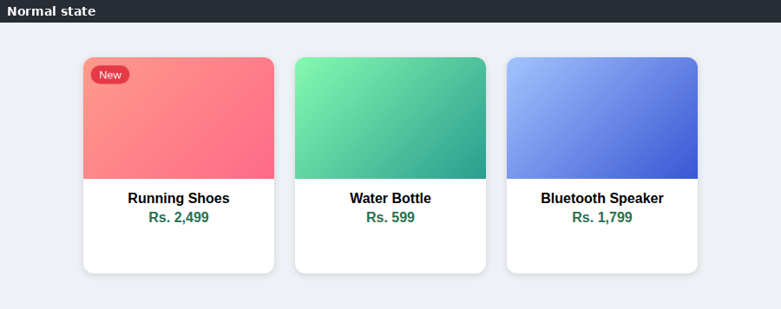
Figure 4: Product cards in the normal state
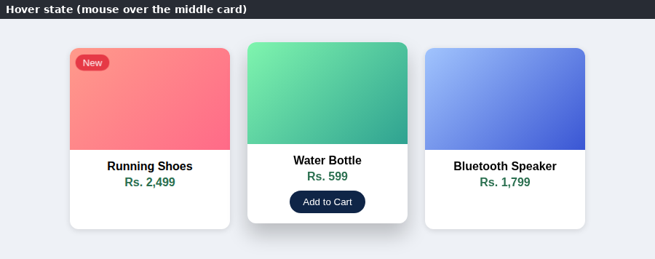
Figure 5: Hover state — the middle card lifts, the image zooms and the button appears
(d) Performance and user-experience considerations
Aspect | Evaluation
Performance | transform and opacity are handled by the GPU compositor and do not cause layout reflow, so the animation is smooth. Properties such as width, height, margin and top should not be animated because they force the browser to recalculate the layout. The box-shadow change is acceptable for a few cards, but a pseudo-element with a pre-drawn shadow whose opacity is animated is cheaper for long product lists.
Touch devices | Phones have no hover, so the rule @media (hover: none) keeps the button always visible. :focus-within gives keyboard users the same effect.
Accessibility | The prefers-reduced-motion query switches animation off for users who are sensitive to motion.
User experience | Short, subtle effects give clear feedback; long or many effects slow the user down. The infinite pulse should be limited to one small element.

Question 3: Layout Selection (Flexbox vs Grid)
Suppose that a dashboard layout needs to be designed for a web application. (a) Identify layout requirements of a dashboard (rows, columns, alignment). (b) Compare Flexbox and Grid based on layout needs. (c) Choose the most suitable layout technique and justify your choice. (d) Evaluate the scalability and responsiveness of the chosen approach.

SOLUTION:
(a) Layout requirements of a dashboard
Requirement | Description
Rows | A header row on top, then rows for key figures (KPIs), charts and activity lists
Columns | A fixed-width sidebar for navigation and a flexible main area with two or more columns
Spanning | The header must span all columns and the sidebar must span several rows
Alignment | Cards must line up in both directions with equal gaps; content inside a card (title left, user right) must be aligned
Responsiveness | On phones the sidebar and cards must stack in one column

(b) Flexbox compared with Grid
Feature | Flexbox | CSS Grid
Dimension | One-dimensional (a row or a column) | Two-dimensional (rows and columns together)
Approach | Content-first: items decide their size | Layout-first: the grid is defined, items are placed into it
Spanning | Cannot span rows and columns together | grid-area, grid-column and grid-row span cells easily
Alignment | Strong along one axis | Aligns items on both axes at once
Best for | Toolbars, menus, button groups, card content | Page layouts, dashboards, galleries
Responsive tools | flex-wrap, flex-basis | grid-template-areas, repeat(auto-fit, minmax())

(c) Choice of layout technique and justification
CSS Grid is the most suitable technique for the main dashboard structure because the page is a two-dimensional arrangement: the header runs across the full width and the sidebar runs down several rows. With grid-template-areas the whole layout can be read like a drawing, and moving to a phone layout only needs a different template. Flexbox is still used inside the individual blocks (the header bar, the KPI row and the bars of the chart), where items follow a single axis. Using Grid for the page and Flexbox for the components gives the best result.
HTML & CSS CODE:
<!DOCTYPE html>
<html lang="en">
<head>
<meta charset="UTF-8">
<meta name="viewport" content="width=device-width, initial-scale=1.0">
<title>Analytics Dashboard</title>
<style>
* { box-sizing: border-box; margin: 0; padding: 0; }
body { font-family: Arial, sans-serif; background: #e9edf4; }
.dash { display: grid; gap: 14px; padding: 14px; min-height: 100vh;
grid-template-columns: 1fr;
grid-template-areas: "header" "side" "kpis" "chart" "activity"; }
.box { background: #fff; border-radius: 10px; padding: 16px;
box-shadow: 0 1px 4px rgba(0, 0, 0, .12); }
.header { grid-area: header; display: flex; justify-content: space-between;
align-items: center; background: #0f2547; color: #fff; }
.side { grid-area: side; }
.side a { display: block; padding: 8px 0; color: #0f2547; text-decoration: none; }
.kpis { grid-area: kpis; display: flex; flex-wrap: wrap; gap: 12px; }
.kpi { flex: 1 1 130px; text-align: center; background: #eaf1fd;
border-radius: 8px; padding: 12px; }
.kpi b { display: block; font-size: 1.5rem; color: #0f2547; }
.chart { grid-area: chart; }
.bars { display: flex; align-items: flex-end; gap: 10px; height: 130px;
margin-top: 12px; }
.bars i { flex: 1; background: #2a6fdb; border-radius: 4px 4px 0 0; }
.activity { grid-area: activity; }
.activity li { list-style: none; padding: 6px 0; border-bottom: 1px solid #eee; }

@media (min-width: 900px) {
.dash { grid-template-columns: 210px 1fr 1fr;
grid-template-areas: "header header header"
"side kpis kpis"
"side chart activity"; }
}
</style>
</head>
<body>
<div class="dash">
<header class="box header"><strong>Sales Dashboard</strong><span>Admin</span></header>
<nav class="box side"><a href="#">Overview</a><a href="#">Orders</a>
<a href="#">Customers</a><a href="#">Reports</a></nav>
<section class="box kpis">
<div class="kpi"><b>1,254</b>Orders</div>
<div class="kpi"><b>Rs. 8.4L</b>Revenue</div>
<div class="kpi"><b>312</b>New Customers</div>
</section>
<section class="box chart"><strong>Weekly Sales</strong>
<div class="bars"><i style="height:45%"></i><i style="height:70%"></i>
<i style="height:55%"></i><i style="height:90%"></i>
<i style="height:65%"></i><i style="height:80%"></i></div></section>
<section class="box activity"><strong>Recent Activity</strong>
<ul><li>Order #1001 delivered</li><li>Order #1002 shipped</li>
<li>New customer signed up</li></ul></section>
</div>
</body>
</html>
OUTPUT:
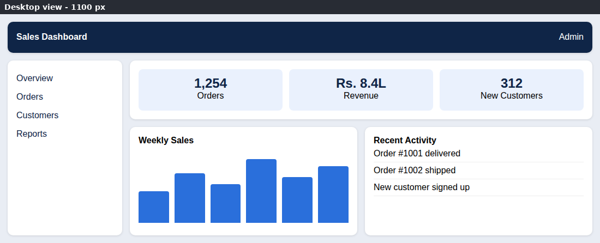
Figure 6: Desktop layout (three columns, sidebar spanning two rows)
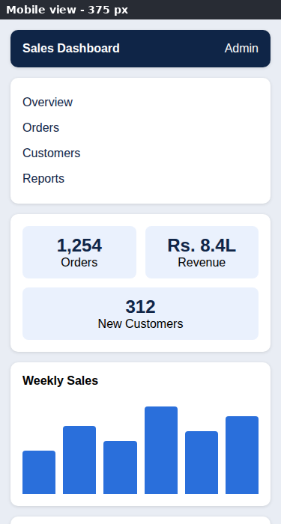
Figure 7: Mobile layout (single column, top part of the page)
(d) Scalability and responsiveness
Aspect | Evaluation
Scalability | A new widget is added by writing one more area name in the template; the existing blocks are not touched.
Responsiveness | The base layout is one column for phones, and a single media query at 900 px creates the three-column layout.
Maintainability | Named areas make the structure easy to read, and the gap property keeps the spacing consistent.
Improvements | Use repeat(auto-fit, minmax(250px, 1fr)) for widget grids, add a collapsible sidebar, use CSS variables for colours and spacing, and consider container queries for components.

Question 4: Mobile-First Blog Layout
Suppose that a blog page must be designed following a mobile-first approach. (a) Identify key sections of a blog layout. (b) Design a mobile-first layout using CSS. (c) Demonstrate how the layout scales for larger screens using media queries. (d) Evaluate accessibility and readability of the design.

SOLUTION:
(a) Key sections of a blog layout
Section | Content | HTML element
Header | Blog name and primary navigation | <header>, <nav>
Main area | List of posts with title, date, reading time and summary | <main>, <article>
Sidebar | About the author, topics, search | <aside>
Footer | Copyright, contact and social links | <footer>

(b) Mobile-first design using CSS
In a mobile-first design the basic CSS describes the smallest screen: a single column, full-width cards and comfortable text. Larger layouts are added later with min-width media queries, so a phone only has to process the simple rules. Semantic elements give the page a clear structure for browsers and screen readers.
HTML & CSS CODE:
<!DOCTYPE html>
<html lang="en">
<head>
<meta charset="UTF-8">
<meta name="viewport" content="width=device-width, initial-scale=1.0">
<title>Mobile-First Blog</title>
<style>
* { box-sizing: border-box; margin: 0; padding: 0; }
body { font-family: Georgia, serif; font-size: 1rem; line-height: 1.7;
color: #1f2937; background: #f3f4f6; }

/* Base styles = mobile: everything in one column */
header { background: #14213d; color: #fff; padding: 1rem; text-align: center; }
nav a { color: #fca311; margin: 0 .6rem; text-decoration: none; }
.layout { padding: 1rem; }
article, aside { background: #fff; padding: 1rem; border-radius: 6px;
margin-bottom: 1rem; }
.thumb { height: 90px; border-radius: 4px; margin-bottom: .6rem;
background: linear-gradient(135deg, #a8c0ff, #3f2b96); }
article h2 { font-size: 1.25rem; }
.meta { font-size: .85rem; color: #4b5563; }
article p:last-child { max-width: 70ch; }
footer { background: #14213d; color: #fff; text-align: center; padding: 1rem; }
a:focus-visible { outline: 3px solid #fca311; outline-offset: 2px; }

/* Tablet: posts in two columns */
@media (min-width: 700px) {
.posts { display: grid; grid-template-columns: 1fr 1fr; gap: 1rem; }
.posts article { margin-bottom: 0; }
}
/* Desktop: posts + sidebar */
@media (min-width: 1000px) {
.layout { display: grid; grid-template-columns: 3fr 1fr; gap: 1.5rem;
max-width: 1100px; margin: 0 auto; align-items: start; }
article h2 { font-size: 1.45rem; }
}
</style>
</head>
<body>
<header>
<h1>Code Diary</h1>
<nav aria-label="Primary"><a href="#">Home</a><a href="#">Posts</a><a href="#">About</a></nav>
</header>
<div class="layout">
<main class="posts">
<article><div class="thumb"></div><h2>Understanding CSS Grid</h2>
<p class="meta">12 Oct 2026 &middot; 4 min read</p>
<p>Grid lets us build rows and columns together with very little code.</p></article>
<article><div class="thumb"></div><h2>Why Go Mobile First?</h2>
<p class="meta">8 Oct 2026 &middot; 3 min read</p>
<p>Start with the smallest screen and add features as space grows.</p></article>
<article><div class="thumb"></div><h2>JavaScript Events Explained</h2>
<p class="meta">2 Oct 2026 &middot; 5 min read</p>
<p>Events connect what the user does to how the page responds.</p></article>
<article><div class="thumb"></div><h2>Accessible Forms</h2>
<p class="meta">25 Sep 2026 &middot; 4 min read</p>
<p>Clear labels and good contrast help every visitor.</p></article>
</main>
<aside><h3>About</h3><p>Notes from a web programming course.</p>
<h3>Topics</h3><p>HTML &middot; CSS &middot; JavaScript</p></aside>
</div>
<footer><p>&copy; 2026 Code Diary</p></footer>
</body>
</html>
(c) Scaling to larger screens with media queries
Screen | Breakpoint | Layout
Mobile | Base styles | Header, posts and sidebar are stacked in one column
Tablet | min-width: 700px | Posts are shown in a 2-column grid
Desktop | min-width: 1000px | 3fr / 1fr grid: posts on the left, sidebar on the right; width limited to 1100 px; larger headings

OUTPUT:
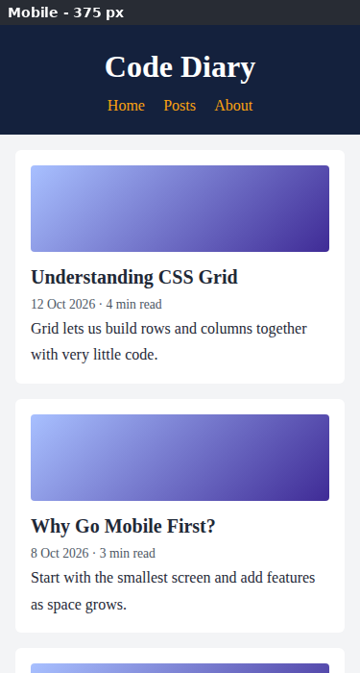
Figure 8: Mobile view (375 px, top part of the page)
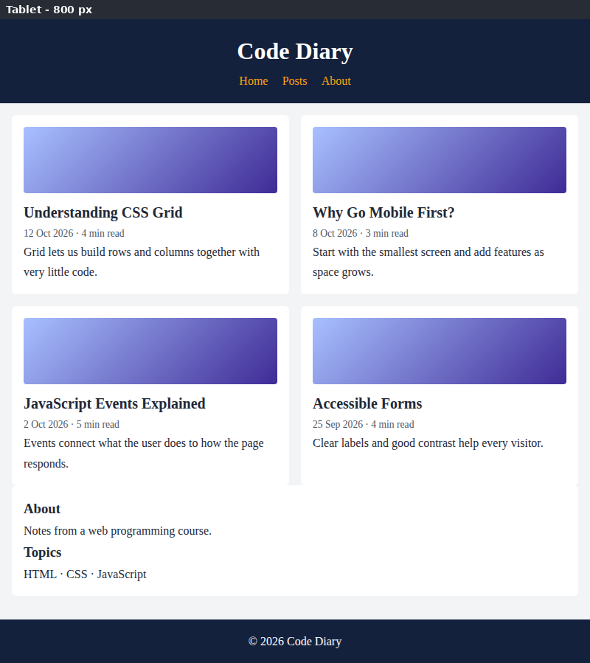
Figure 9: Tablet view (800 px)
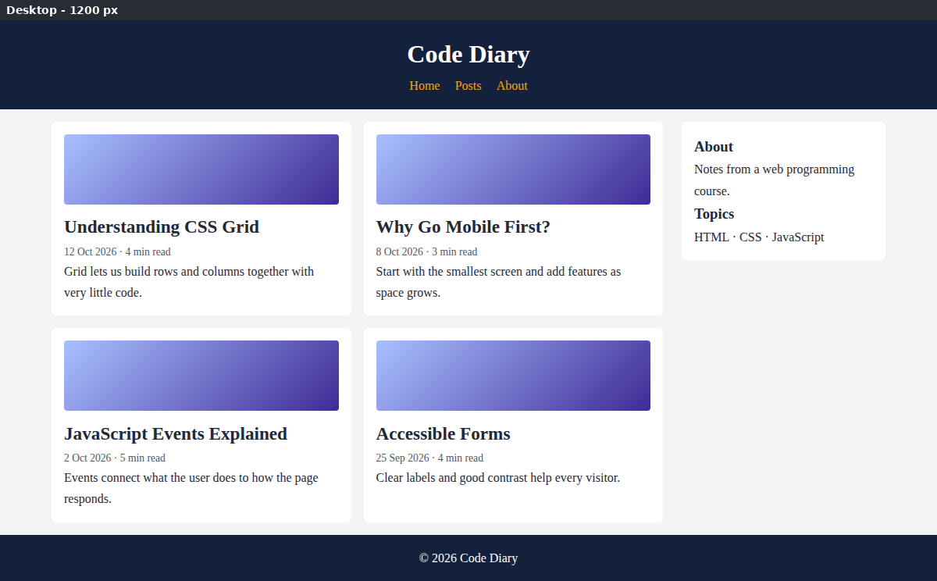
Figure 10: Desktop view (1200 px)
(d) Accessibility and readability
Aspect | Evaluation
Readability | A line-height of 1.7, a base font of 1 rem and a text width limited to 70 characters (max-width: 70ch) make the text comfortable to read.
Structure | Semantic elements, one h1 and ordered headings help screen-reader users to navigate.
Contrast and focus | Dark text on a white card gives strong contrast, and :focus-visible draws a clear outline around links.
Responsiveness | The viewport tag and relative units (rem, fr) let the layout follow the device and the user’s font settings.
Improvements | Add a “skip to content” link, alt text for every image, larger tap areas for navigation links and a dark mode with prefers-color-scheme.

Question 5: JavaScript Event Handling for Dynamic Menu
Suppose that a website includes a dynamic menu that responds to user interactions. (a) Identify appropriate JavaScript events for menu interaction. (b) Design event handling logic for menu toggle functionality. (c) Implement interaction for user actions (click/hover). (d) Evaluate performance and suggest improvements.

SOLUTION:
(a) Appropriate JavaScript events
Event | When it fires | Use in the menu
click | Button pressed or tapped | Open or close (pin) the menu; select an item
mouseenter / mouseleave | Pointer enters or leaves an element (does not bubble) | Preview the menu on hover
keydown | A key is pressed | Escape closes the menu; arrow keys move between items
focus / blur | Element gains or loses focus | Keeps the menu usable with the Tab key
click on document | A click anywhere on the page | Closes the menu when the user clicks outside

(b) Event-handling logic for the toggle
Step | Logic
1 | Select the button, the list and the status text with getElementById.
2 | Write one function setOpen(open) that toggles the CSS class “open”, updates aria-expanded and changes the status text.
3 | On button click, flip the flag “pinned” and call setOpen(pinned). stopPropagation() prevents the document click handler from closing the menu at once.
4 | On mouseenter open the menu, and on mouseleave close it, but only if it is not pinned and the device supports hover.
5 | On a document click outside the menu, or on the Escape key, clear the flag and close the menu.
6 | Use event delegation: one click listener on the list reacts to every menu item and shows the choice.

(c) Implementation of click and hover interaction
HTML, CSS & JAVASCRIPT CODE:
<!DOCTYPE html>
<html lang="en">
<head>
<meta charset="UTF-8">
<meta name="viewport" content="width=device-width, initial-scale=1.0">
<title>Dynamic Dropdown Menu</title>
<style>
body { font-family: Arial, sans-serif; margin: 0; }
.bar { background: #0f2547; color: #fff; padding: 12px 18px;
display: flex; align-items: center; gap: 18px; }
.dropdown { position: relative; }
#menuBtn { background: transparent; color: #fff; border: 1px solid #fff;
padding: 6px 14px; font-size: 1rem; cursor: pointer; border-radius: 4px; }
#menuList { display: none; position: absolute; top: 110%; left: 0;
min-width: 190px; margin: 0; padding: 0; list-style: none;
background: #fff; border-radius: 6px; overflow: hidden;
box-shadow: 0 6px 16px rgba(0, 0, 0, .25); }
#menuList.open { display: block; }
#menuList a { display: block; padding: 11px 16px; color: #222;
text-decoration: none; }
#menuList a:hover, #menuList a:focus { background: #e6eefb; outline: none; }
#status { padding: 18px; }
</style>
</head>
<body>
<div class="bar">
<div class="dropdown" id="dropdown">
<button id="menuBtn" aria-haspopup="true" aria-expanded="false"
aria-controls="menuList">&#9776; Menu</button>
<ul id="menuList">
<li><a href="#">Home</a></li>
<li><a href="#">Products</a></li>
<li><a href="#">Orders</a></li>
<li><a href="#">Contact</a></li>
</ul>
</div>
<span>My Store</span>
</div>
<p id="status">Menu is closed.</p>

<script>
const dropdown = document.getElementById("dropdown");
const button = document.getElementById("menuBtn");
const list = document.getElementById("menuList");
const status = document.getElementById("status");
const items = list.querySelectorAll("a");
let pinned = false; // true when opened by a click

function setOpen(open) {
list.classList.toggle("open", open);
button.setAttribute("aria-expanded", String(open));
status.textContent = open ? "Menu is open." : "Menu is closed.";
}

// click: pin the menu open / closed
button.addEventListener("click", function (e) {
e.stopPropagation();
pinned = !pinned;
setOpen(pinned);
});

// hover: preview the menu on devices that support hover
if (window.matchMedia("(hover: hover)").matches) {
dropdown.addEventListener("mouseenter", function () { if (!pinned) setOpen(true); });
dropdown.addEventListener("mouseleave", function () { if (!pinned) setOpen(false); });
}

// click outside closes the menu
document.addEventListener("click", function (e) {
if (!dropdown.contains(e.target)) { pinned = false; setOpen(false); }
});

// keyboard: Escape closes, arrow keys move between items
document.addEventListener("keydown", function (e) {
if (!list.classList.contains("open")) return;
const i = Array.prototype.indexOf.call(items, document.activeElement);
if (e.key === "Escape") { pinned = false; setOpen(false); button.focus(); }
if (e.key === "ArrowDown") { e.preventDefault(); items[(i + 1) % items.length].focus(); }
if (e.key === "ArrowUp") { e.preventDefault(); items[(i - 1 + items.length) % items.length].focus(); }
});

// event delegation: one listener handles every menu item
list.addEventListener("click", function (e) {
if (e.target.tagName === "A") {
e.preventDefault();
status.textContent = "You selected: " + e.target.textContent;
pinned = false;
list.classList.remove("open");
button.setAttribute("aria-expanded", "false");
}
});
</script>
</body>
</html>
OUTPUT:
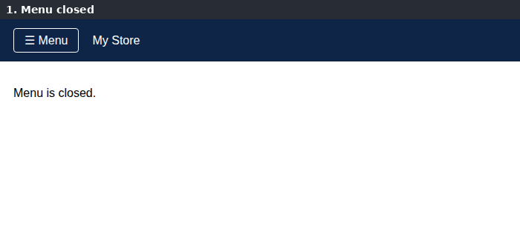
Figure 11: Menu closed
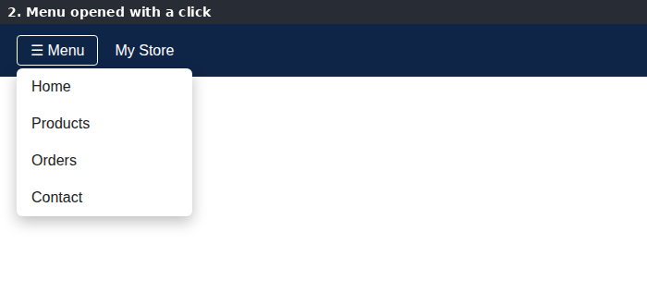
Figure 12: Menu opened with a click (hover shows the same preview)
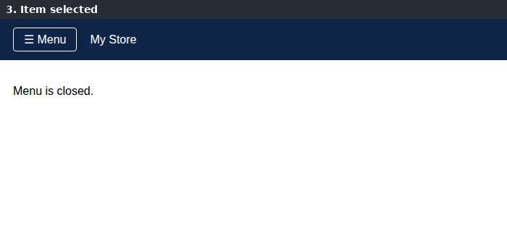
Figure 13: A menu item is selected and the menu closes
(d) Performance evaluation and improvements
Evaluation: the menu is opened and closed by toggling one CSS class, which is fast because styles are not changed one by one. Event delegation uses a single listener for all items, and the page works with mouse, touch and keyboard. The aria-expanded attribute tells screen readers whether the menu is open.
Suggested improvements:
- Use { passive: true } for scroll and touch listeners, and throttle or debounce events that fire often (resize, scroll, mousemove).
- Add role="menu" and role="menuitem" and keep focus inside the menu while it is open.
- Animate the opening with CSS transitions (opacity and transform) instead of JavaScript timers.
- Remove listeners that are no longer needed and keep the logic in one reusable function or module.

Code of Conduct:
I K VENKATA SIVA PRASAD 192325106 certify that this submission is my original work and that I have adhered to the guidelines specified for this assessment. I understand that any violation of academic integrity rules will result in disciplinary action.

Signature of the student: K VENKATA SIVA PRASAD

